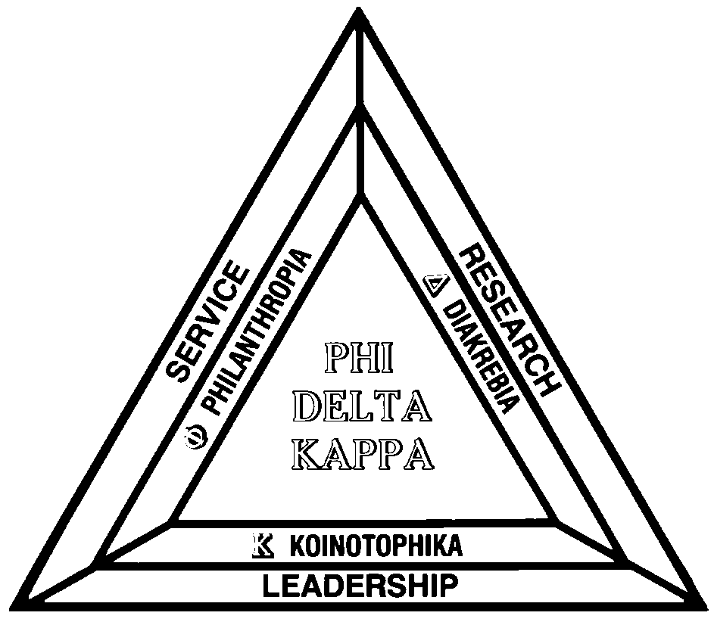
Phi Delta Kappa
University of Kentucky Chapter #037
September, 2000 Newsletter

Chapter Officers
2000-2001
COME HEAR THE NEW SUPERINTENDENT OF FAYETTE COUNTY SCHOOLS
Monday, September 18

The UK Phi Delta Kappa Chapter is proud to begin its 2000-2001 meeting schedule on Monday, Sept 18, at Veteran’s Park Elementary School, 4351 Clearwater Way, LX, 40515, with a talk by Dr. Robin Fankhauser. Dr. Fankhauser, a 19 year member of PDK will use as her topic, “How the lessons I learned from children's literature are guiding me as a superintendent.”
This will be a dessert meeting. The fee per member is $6.00. RSVP by noon, Friday, September 15… to Willis Johnson, treasurer, 257-3158 or wjohnson@pop.uky.edu.

President, Robb Gaskins
VP Programs, Carla Beranek
VP Membership, Cathy Bell
Secretary, Rosetta Sandidge
Treasurer, Willis Johnson
Foundation Representative, Linda Holbrook
Historian, Roger Jones
Newsletter, Gary Schroeder
Advisor, Katherine McCormick
Delegate, Ed Sagan
Research Representative, Jane Clark Lindle

2000-2001 MEETING SCHEDULE, UK PHI DELTA KAPPA CHAPTER

Monday, September 18, 7:00 p.m., Veterans Park Elementary School
Speaker: Robin Fankhauser, Superintendent, Fayette County Schools
Dessert Meeting
Wednesday, October 25, 12:00 p.m., Meeting Room, Café Joseph Beth, Joseph-Beth Booksellers, Lexington Green
Speaker: Mary Ann Vimont – Topic: Economic Education
Lunch Meeting
Friday, December 15, 6:30 p.m., UK Faculty Club
Social Event/Celebration/Initiation
Celebratory Reception Meeting
Thursday, February 22, 7:00 p.m., Location to be announced
Program Convener: Carol Moffitt… Topic: Assistive Technology Today
Dessert Meeting
Wednesday, March 28, 7:00 p.m., School for the Creative and Performing Arts
Program Convener, Carla Beranek… Topic: Tour of New Facility
Dessert Meeting
Tuesday, May 8, 7:00 p.m., UK Faculty Club
Program Convener: Cathy Bell… Topic: Initiation and Awards Ceremony
Dessert Meeting

All meetings take place at 7PM, except for the December 15 Initiation and Social event, which is at 6:30PM. All programs require an RSVP, and each will have a nominal fee to cover the cost of the food, except for the lunch meeting at Café Joseph Beth, at which members will order from the menu.

PHI DELTA KAPPA, UNIVERSITY OF KENTUCKY CHAPTER, SEPTEMBER, 2000………………..PAGE 2
FROM THE PRESIDENT’S PEN…. Greetings! The Board of Directors for the UK Chapter of Phi Delta Kappa worked hard this summer to create a schedule of meetings that will offer dynamic speakers, exciting topics of discussion, interesting and varied venues, and the opportunity for lots of fun. The result is a great schedule of meetings that I feel confident everyone will enjoy.
Our first meeting is Monday, September 18 at 7:00 p.m. at Veterans Park Elementary School. We are honored to have as our first speaker for the year, Robin Fankhauser, the Superintendant of Fayette County Public Schools. I am looking forward to hearing her speak! In addition to having a wonderful speaker, the meeting will also feature a delicious dessert! So there you go - An outstanding speaker, interesting and important topics of discussion, a beautiful setting, excellent company, and good food. Be sure not to miss this all around great event!
Our second meeting of the year is Wednesday, October 25, at noon at Joseph-Beth Booksellers. This meeting will feature Mary Ann Vimont discussing her important and fascinating work promoting and teaching Economics Education in local schools. You will enjoy hearing Mary Ann share her stories about and insights into this critical topic and you will marvel at all that she has accomplished. Be sure to place this lunch meeting on your calendar!
I could easily fill up the newsletter by myself discussing each meeting in detail, but I will save some of those discussions for future newsletters. This year looks to be a great one for our chapter, and I hope to see you at many meetings.

Robb Gaskins



A PDK MEETING, LUNCH, AND A TRIP TO THE BOOKSTORE… What could be better?
On Wednesday, October 25, at noon, we will have our 2nd chapter meeting… a first at Café Joseph Beth, in Lexington Green. Join us to hear renowned speaker Mary Ann Vimont on the topic of Economics Education. The deadline to RSVP is October 20, to Willis Johnson, 257-3158, or better yet, by email to wjohnson@pop.uky.edu. Lunch is from the menu.
DISTRICT VIII CONFERENCE ANNOUNCEMENT
Chapter Delegate Ed Sagan tells us that the PDK District VIII conference will be taking place in Charlotte, NC, Oct. 12-15. The district conferences are held every other year, in the fall. Delegates to the district conference (Ed Sagan, for us) consider and recommend legislation to the Legislative Council. Under the PDK Int. governance plan, all chapters must have a delegate in attendance at the district conference. District VIII includes chapters in KY, VA, NC, SC and TN.
CHAPTER ANNOUNCEMENTS….
Deceased:
Rawdy Whittaker, 96, a 34 yr member of PDK. From Clay County, he was a school administrator in KY and OH for 49 years.
Charles Leland Smith, Emeritus UK College of Education faculty member, and 40 year PDK member.
Birthday Greetings:
Charles H. Quillings, 80, 35 year membership award.

PHI DELTA KAPPA, UNIVERSITY OF KENTUCKY CHAPTER, SEPTEMBER, 2000………………..PAGE 3

NEW MEMBERS OF THE UK PHI DELTA KAPPA CHAPTER
The following new members were initiated into the UK chapter this past summer;
Camellia Heckler Baxter, Carla Beranek, sponsor… Camellia is a middle school teacher at SCAPA in Fayette County.
William Paul Bintz, Robb Gaskins, sponsor… William is an Assistant Professor in Elementary Education at UK.
Elinor L. Brown, Robb Gaskins, sponsor… Elinor is an Assistant Professor in Social Studies and Multicultural Education at UK.
Christine Ann Christle, Beth Ann Pruitt, sponsor… Christine is a graduate student in Special Education at UK.
Denise Beeler Jones, Sharon Brennan, sponsor… Denise is a coordinator of field experiences for the UK College of Education.
Carol D. Moffett, Al Cinson, sponsor… Carol is a coordinator of Assistive Technology for Fayette County Schools.
Naah Yemeh, Robb Gaskins, sponsor… Naah is a graduate student in Curriculum and Instruction at UK.

To our members…
Welcome to a new school year! The summer seemed short but hopefully you were able to rest and rejuvenate.
It is with excitement and enthusiasm that I serve on the board as Vice President for Membership with PDK. The organization has provided support to me through projects, programs and publications, so it seemed appropriate to “give back” in some way. Working with the board will be a new venture.
Please join us in our efforts to bring excellence to education by taking a moment to renew your membership with Phi Delta Kappa International. If you are a member in good standing, please think about nominating someone for membership. We value you as a member of our chapter and hope that you will enhance your association with PDK becoming more involved and involving others. It is our goal to increase membership by three percent this year, and it takes your nomination to make that happen. I hope you will help us reach that goal.
Please feel free to contact me if you have questions about any aspect of membership. Have a great school year!
Sincerely,

Cathy Bell, VP for Membership

2000-2001 INITIATION DATES:

Friday, December 15, 6:30 PM, UK Faculty Club
Tuesday, May 8, 7 PM, UK Faculty Club.
Candidates must attend an initiation to become a member of Phi Delta Kappa.
OUR THREE-PRONGED RECRUITMENT STRATEGY
UK Phi Delta Kappa wishes to secure new members from Fayette and surrounding school systems, the University of Kentucky, and other area institutions of higher education.

PHI DELTA KAPPA, UNIVERSITY OF KENTUCKY CHAPTER, SEPTEMBER, 2000………………..PAGE 4
CONTACT YOUR PHI DELTA KAPPA LEADERS….
Bell, Cathy, VP Membership cbell@Fayette.k12.ky.us… Cathy Bell is Principal at Veteran’s Park Elementary, Fayette County
Beranek, Carla, VP Programs CBERANEK@Fayette.k12.ky.us… Carla Beranek is Itinerant Staff Assistant at the School for Creative and Performing Arts, Fayette County
Gaskins, Robb, President RGASK01@pop.uky.edu… Robb Gaskins is Associate Professor of Education, University of Kentucky
Holbrook, Linda, Foundation Representative lholbroo@kde.state.ky.us… Linda Holbrook is Language Arts Consultant for the Kentucky Department of Education
Johnson, Willis, Treasurer wjohnsn@pop.uky.edu… Willis Johnson is Professor of Education, University of Kentucky.
Lindle, Jane Clark, Research Representative jclind00@pop.uky.edu… Jane Clark Lindle is Professor of Education, University of Kentucky
McCormick, Katherine, Chapter Advisor kmcco2@pop.uky.edu…. Katherine McCormick is Associate Professor of Education, University of Kentucky
Sagan, Ed, Delegate EMSAGAN@prodigy.net… Ed Sagan is former Dean, University of Kentucky
Sandidge, Rosetta, Secretary Sandidg@pop.uky.edu… Rosetta Sandidge is Associate Dean, College of Education, University of Kentucky
Schroeder, Gary, Newsletter Editor Gschr1@pop.uky.edu… Gary Schroeder is Director of Academic Services, College of Education, University of Kentucky
Proffitt, Eve, PDK International President eproffitt@mail.state.ky.us… Eve Proffitt, is Director of the Kentucky School Boards Association.
Cinson, Al, PDK Area 8B Representative acinson@fayette.k12.ky.us… Al Cinson is TV Producer Director for the Fayette County Schools.

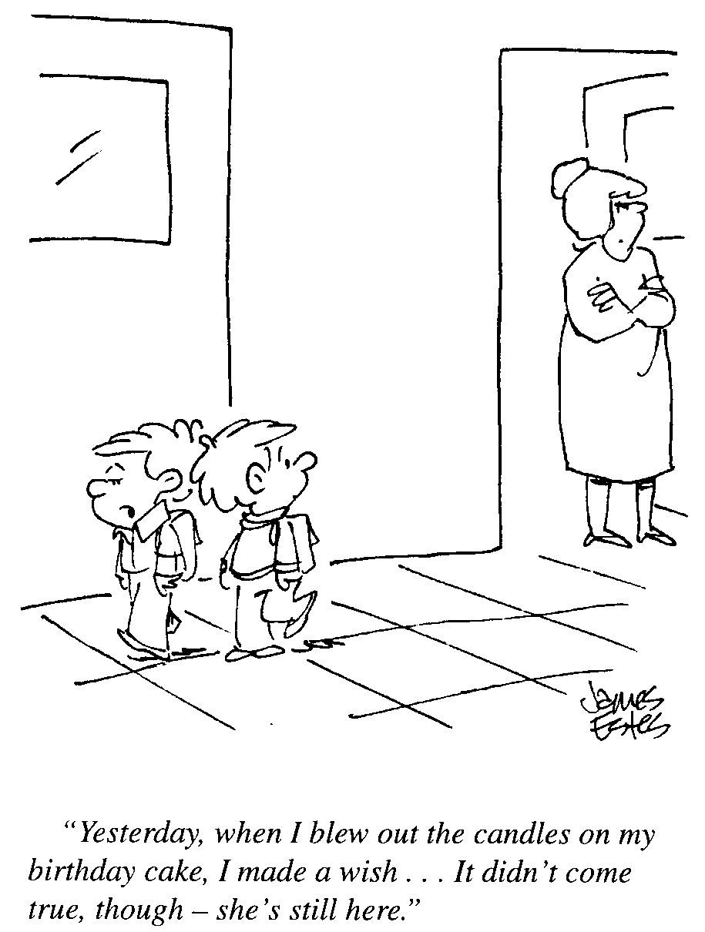
Teaching is A Lot Like Farming

Teaching is a lot like farming, where you have to take into account the weather, soil, equipment, markets, seed quality, etc.
Some farmers work magic even in terrible conditions. So do some teachers. If a school were a business, the faculty would be
what a school had to sell. Other things count, but in the end, the quality of the school depends upon the quality of teaching.

Lamar Alexander, President, University of Tennessee



PHI DELTA KAPPA MEMBERSHIP INFORMATION

Who Can Apply?
- Professional Educators in all areas and at all levels
- Students—undergraduates pursuing a degree for licensure or certification in education, student teachers, graduate students

What are the different types of membership?
PDK offers two types of membership. The first is called regular membership. This membership is open to professional educators, individuals in education-related fields, graduate students and student teachers. Regular members are entitled to all membership services and benefits, voting privileges and the right to hold volunteer leadership positions. A second type of membership is offered to undergraduate students who are embarked on a course leading toward certification/licensure in education. This is an introductory membership. It is for one year only, and it is not renewable. Undergraduate students are not initiated into PDK, do not have voting privileges, and can not hold official leadership positions.

What does it cost to join the UK Phi Delta Kappa Chapter?
Regular members pay $60.00 on initiation. This includes $45.00 PDK dues, $10.00 chapter dues and $5.00 initiation fee.
Undergraduate members pay $27.50 upon joining. This includes $22.50 PDK dues, and $5.00 chapter dues.
Email the Membership Chair, Cathy Bell at cbell@fayette.k12.ky.us for additional information or to nominate yourself for membership (after which you will be contacted to be sponsored by a member).

IF YOU NOMINATE……
1) A candidate must attend an initiation ceremony to become a member of Phi Delta Kappa.
2) The initiations for 2000-2001 are on the evenings of Friday, Dec 15, 2000 at the Boone Faculty Club, 6:30 PM, and Tuesday, May 8, 7PM at the Boone Faculty Club. All initiates are the guests of the chapter.
3) Paperwork for the initiate should reach Cathy Bell, membership chair, Veteran’s Park Elementary School, 4351 Clearwater Way, Lexington, KY 40515, no later than one week before the initiation date. Phone: 381-3161
4) Candidate sponsors are requested to attend the initiation ceremony with their nominees.
5) Candidates should be prepared to give a check for $60.00 to the membership chair at the time of the initiation.

Need some forms?? Application for Membership. Application for Undergraduate Student Membership. Application for Reinstatement to Good Standing Membership. Application for Membership Transfer. Application for Dual Membership. Application for Senior Membership. Email Gschr1@pop.uky.edu, or call 859-257-7971.

