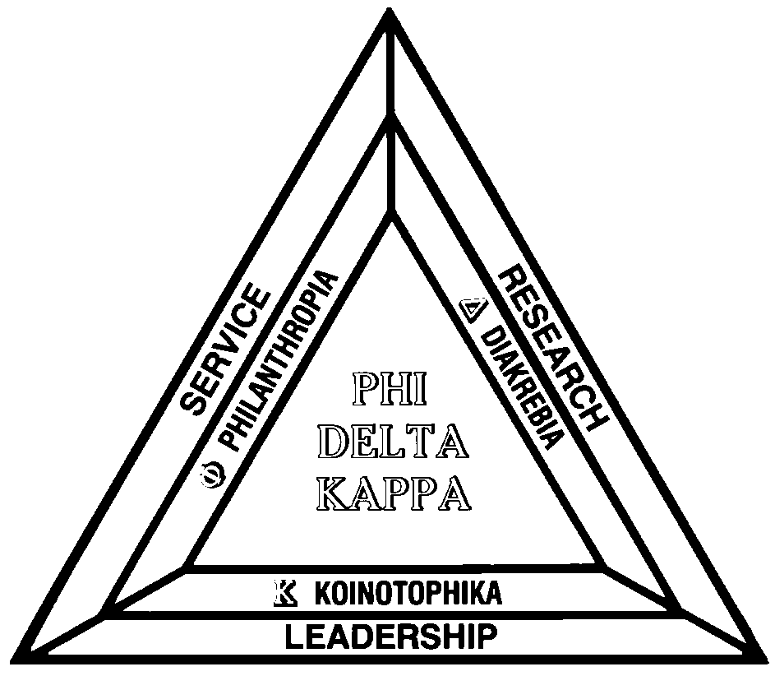
Phi Delta Kappa
University of Kentucky Chapter #037
September, 2002 Newsletter
75th Anniversary
Chapter

Message from your President, Connie Evans:

Your PDK officers and I welcome you to the new school year and to a new year with PDK. Using the results of our survey, the Board has met to discuss and plan PDK activities for Fall 2002 and Spring 2003. Please put the following dates on your calendar now and plan to be with us at these all-chapter functions.
Our first activity will be held on Monday, September 23 at 7:30 a.m. at the Keeneland Track Kitchen. For those of you who have never eaten at the Track Kitchen we think you are in for a treat. The food is delicious and inexpensive. The cost of the breakfast will be on your own, but we will be in a private dining room so that we can have good conversation and enjoy our colleagues. Do plan to attend AND bring a potential member or another member with you. This will be a great way to celebrate the first day of Autumn!
As we mentioned to you in our survey newsletter, we are going to offer interest groups that members can choose to participate in according to their needs. These are:
Research/publication - Gary Schroeder will be the lead person for this group. He may be reached at: 859-257-8691 and/or gschr1@uky.edu
Principals - Andy Biggers will be the lead person for this group. He may reached at: 859-744-2243 and/or abiggers@clark.k12.ky
Political Action - I will be the lead person for this group and may be reached at 859:272-4663 and/or cm.evans@verizon.net

If you checked any of these groups on your survey card, you will be receiving a phone call or email from the leader of the group. The members of the group will determine meetings times and topics. If you did not check any of these groups on your survey card but would like to participate, please call or email the lead person.
I’m sure that all of you have been following our national organization’s efforts to rethink the form and structure of Phi Delta Kappa International. What we are going to try here in Central Kentucky is our own version of that kind of visionary restructuring. It will be a challenge, but it might very well make the organization into something which will better meet the needs of all of our members.
Please join us in this ambitious undertaking.
Connie

PHI DELTA KAPPA, UNIVERSITY OF KENTUCKY CHAPTER, SEPTEMBER, 2002…PAGE 2

UK PHI DELTA KAPPA SCHEDULE OF COMMON MEETINGS, 2002-2003

Annual UK Phi Delta Kappa Breakfast at Keenland. Monday, September 23, 7:30am
Monday, September 23 at 7:30 a.m. at the Keeneland Track Kitchen.
The Track Kitchen is out around the back at the Keeneland Racetrack. Go in the front entrance to Keenland at the Man O’War intersection. Follow the road all the way around to the back… you can’t miss it.
We’ll gather, get our food, and hear some welcoming news from Connie, Eve, Al, and Andy. Bring a friend and introduce them to the friendly folks in the UK chapter.
December Initiation and Holiday Social, Wednesday, December 4, 6:30pm
In December, we’ll gather for the holiday dinner/initiation of new members. We will meet at 6:30 p.m. on Wednesday, December 4 at the Faculty Club on UK's campus. Further details will be in another newsletter. Please be thinking of an educator you would like to nominate to become one of us.
Year End Wrap Up and Initiation, Wendesday, April 23, 5:30pm
The spring activity will also be a dinner/initiation and will be held on Wednesday, April 23, 2003 beginning at 5:30 at Spindletop Hall. Additional details and surprises will be announced at a later date.

How about a telephone tree?

Many of you have commented that it might help meeting attendance if more of an effort was made to make personal contact with our members.
Sooooo…. We’re going to try a telephone tree.
If you want to volunteer… contact Connie Evans.
Or… if we phone to give you an assignment… please say yes!!!
Happy birthday to you
Happy birthday to you
Happy birthday dear uk phi delta kappa
Happy birthday to you….
How old are you??
Seventy five years… that’s (75) years.
Watch for announcements of special events during this very special year for the UK PDK chapter
The University of Kentucky Chapter was installed as the 51st chapter in PDK on April 14, 1928.

PHI DELTA KAPPA, UNIVERSITY OF KENTUCKY CHAPTER, SEPTEMBER, 2002…PAGE 3

And now…. A word from Al Cinson, our PDK Foundation Representative
As the Foundation Representative for PDK this year, I wanted to let members know that you can donate the requested $5 amount by a check on your renewal dues card each year and International will bill you accordingly. Also I have Foundation renewal cards I hope to be mailing soon to each member, this requests you send in $5 by return mail. The Foundation, as you may know, is a very worthwhile program that supports many activities throughout the organization. Without your support many activities would not be available to members. Your strong support to the Foundations program keeps PDK and it's programs current for many of us to enjoy. Please be as generous as possible.

Thanks for you continued support. Al Cinson, Foundation Representative

In the survey that went out in August the possibility of participating in a principal's group drew a large number of interested respondents. The PDK officers met, looked at the data and came up with a general direction for this group. Andy Biggers will start the ball rolling by contacting each person who expressed a desire to join this group. From there plans will be made for principals to meet with teacher candidates (and professors/deans) from one or more of our local college teacher preparation programs. Yet to be determined: number of meetings, dates, formats, and of course the food! When these points are finalized with input from respondents our principal's group will become a reality! Comments and questions should be addresses to Andy. [abiggers@clark.k12.ky.us]

Connie Evans is the group leader for the political action group. She believes that our chapter has so many resources among our members and so much expertise and we also know firsthand the problems teachers and administrators are facing daily in our schools. This group will begin forming liaisons with legislators and starting to involve the chapter with legislation concerning education. Will our chapter be outside the capital waving placards? Probably not! But we will begin surveying the political scene in Frankfort and helping the rest of the chapter know what kinds of issues are hot (and not), and where our members ought to be extending their knowledge and experience to help legislators and staff better understand education matters. Contact Connie at cm.evans@verizon.net

Why so many of us got into education in the first place was that we loved scholarship and research. Often we wish there was more emphasis on the scientific study of education among our students, the public, and ourselves. PDK is an organization with a mission to promote research in education. What could be a better subgroup for the chapter than one to bring us together around topics related to research and scholarship? This group will come together for that purpose. We hope to involve our colleagues at other area institutions of higher education, and to focus on ways to raise research issues for a wider public. Hopefully there will be both a fall and spring meeting of the group, which will be announced, in the next newsletter. Contact: Gary Schroeder, gschr1@uky.edu.
PRINCIPALS AND ADMINISTRATOR’S GROUP
POLITICAL ACTION GROUP
RESEARCH, PUBLICATION, AND HIGHER EDUCATION GROUP

PHI DELTA KAPPA, UNIVERSITY OF KENTUCKY CHAPTER, SEPTEMBER, 2002…PAGE 4

Responses to the Late Summer Survey of Members

Fifty-six members responded to our PDK survey. Here are their responses:
25 indicated they would attend a luncheon/dinner with a speaker
18 indicated they would attend initiation with a meal
33 indicated they would participate in an interest group.
12 were interested in the principals' group
8 in the political action group;
4 in research/ publication;
4 in special projects; 3 in social;
2 in service.
7 checked they would serve on a phone tree;
4 checked they would submit articles/letters for the newsletter
4 indicated they would be more likely to attend chapter activities if EILA/PD credit could be offered; 19 said it would not make a difference
20 planned to continue their membership in PDK but did not want to be actively involved at this time.

University of Kentucky Chapter 037
2002-2003 75th Anniversary Chapter Officers

President
Connie Evans, 859-272-4663, cm.evans@verizon.net

VP/Membership
Kristine S. Jolivette, 859-257-7906, kjolive@uky.edu

VP/Program
Andy Biggers, 859-381-3533, aabigger@fayette.k12.ky.us

Secretary
Rosetta Sandidge, 859-257-8847, sandidg@uky.edu

Treasurer
Willis Johnson, 859-257-3158, wjohnsn@uky.edu

Newsletter Editor
Gary Schroeder, 859-257-8691, gschr1@uky.edu

Research Representative
Robb Gaskins, 859-269-2735, rgask01@uky.edu

Advisor
Katherine McCormick, 859-257-9573, kmcco2@uky.edu

Foundation Representative
Al Cinson, 859-281-0254, acinson@fayette.k12.ky.us

Delegate
Ed Sagan, 859-257-6076, sagan@coe.uky.edu
SCHOLARSHIP GROUP….
Al Cinson has his hands full as Foundation Representative. One of his jobs is working to identify scholarship recipients. Al is looking for a few good people to help out. Contact him at acinson@fayette.k12.ky.us

SCHROEDER’S PICKS FROM THE KAPPAN

The September 2002 issue of the Phi Delta Kappan is OUTSTANDING. If you read nothing else, don’t miss Kathy Christle’s “Getting Policy Makers Literate on Literacy.” To me this is a wakeup call to all educators… but read for yourself. John I. Goodlad presents a research view of current reform in his article “Kudzu, Rabbits and School Reform,” and introduces the concept of eduviruses. For those struggling to deal with education these days, John is right on the money. And, finally Anne C. Lewis’ commentary, “Where is the NCLBA Taking U” is something EVERYONE should read.

